**Background**

**Hernan Cortés**

Hernán Cortés is considered by his revisionists as a man of complex nuances, he combined judgment and audacity, he had great resilience in the face of adversity, brave, cunning and intelligent, with a strong and predominant leadership among his hosts, charismatic and seductive in speech and that caused a veiled antagonism among his peers.

During the conquest, he knew how to demonstrate cruelty in the face of the evidence of treason, protecting himself with the Christian faith in the most radical way and he did not hesitate to apply the worst punishments to friends and enemies; but in turn, he was benevolent towards the vanquished. Governed by great ambition, he aspired to be not only to be considered as part of the Spanish nobility; but to establish himself as a viceroy in Mesoamerica and that motivated his desire to conquer to gain recognition by King Carlos V.

**Spaniards**

Loyal followers of its captain Hernán Cortés, adventurers and thirsty for gold. Christians and with faith to King Carlos V. From the majority of Cuba. They would do whatever their captain asks of them, even if it is the bloodiest massacre as in Cholula. Besieged in a temple desperate to flee the city.

**Tlaxcaltecans**

Subjected to the Mexica Empire, spiteful in taking away the tributes and women. Always rivals of the Mexicas, supporting Hernan after losing against him, with the idea of destroying the empire that subdues them. Always in conflict with the Spanish, but a common goal, to take Tenochtitlan.

**Mexicas**

People from the central empire of Mesoamerica, with a strong military power, with alliances and their army were almost unthinkable, mainly debating the God of war Huitzilopochtli, hence their culture of war and conquests in Mesoamerica. Furious against the Spanish for the blood spilled in the main temple, they want revenge and their Tlatoani does not seem that they can give it to them.

**Scene Selection**

The following scene is selected for evaluation

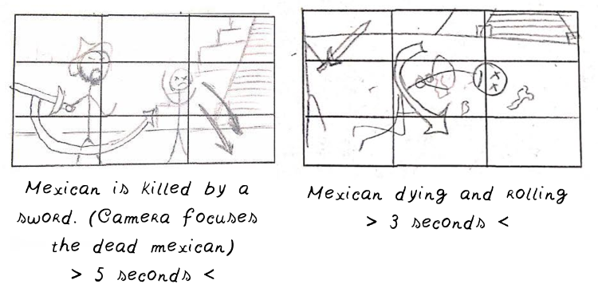

They are the first 2 scenes created in blender at the following link:

<https://github.com/MarcoGrimaldo/Computer-Animation/blob/master/Blender/Animation.blend>

This scene is selected due to the fact that it has been the most complete scene regarding animation (details are shown below), since for COVID-19 reasons it did not allow me to finish beyond scene 5.

**Comparison**

**1.-**

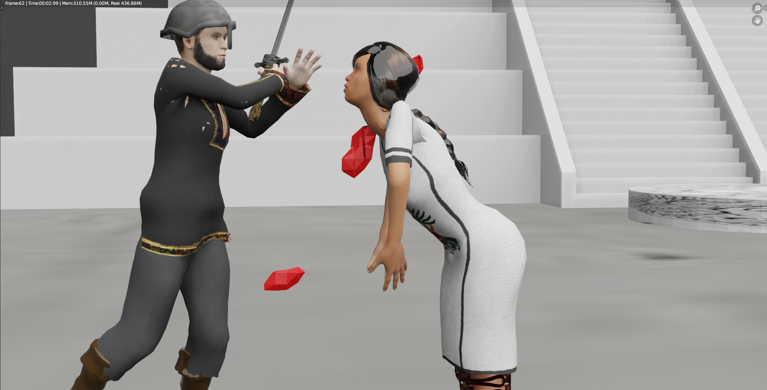

**2.-**



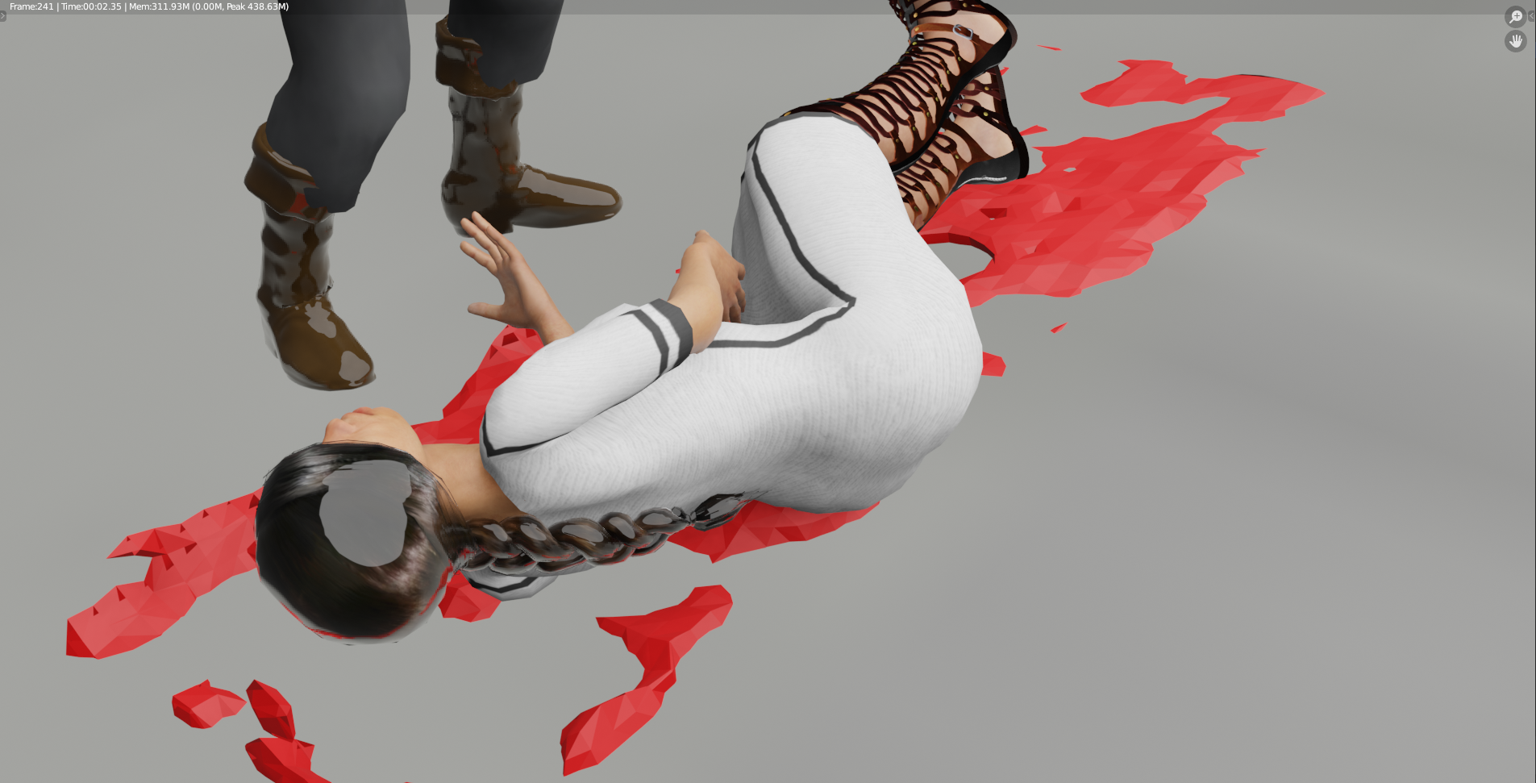

**Description**

In this first scene the massacre in the main temple is shown, an armed Spaniard assassinates a defenseless Mexican woman. The feeling that we are trying to convey is anger, resentment, or helplessness, all those feelings that the Mexica people had after this massacre and that gave rise to the Tlatoani's ignorance and later what I would like to call “The revenge Night”.

**Principles of animation**

The animation principles used are:

2. - Anticipation: The Spanish anticipates his blow with the sword taking the space to make a stronger blow

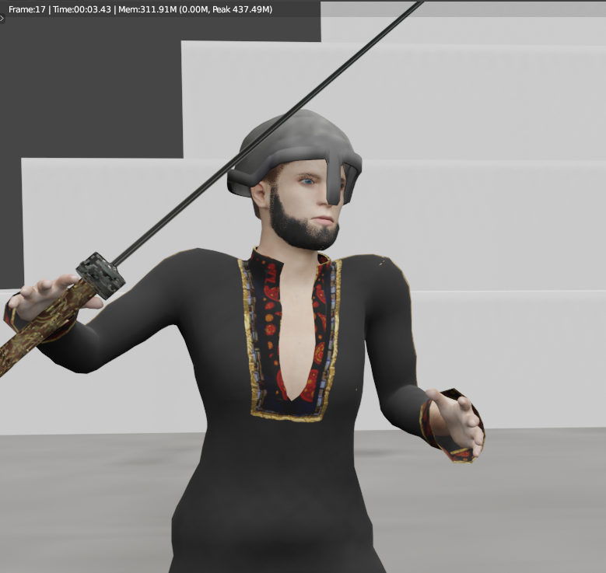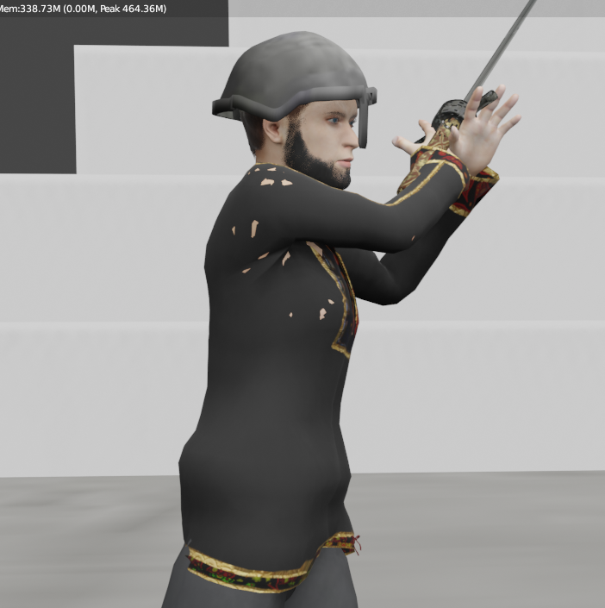

3. - Staging: The most important beginning of this scene, the camera focuses on the wounded and dying Mexican to convey the aforementioned feeling of hatred.

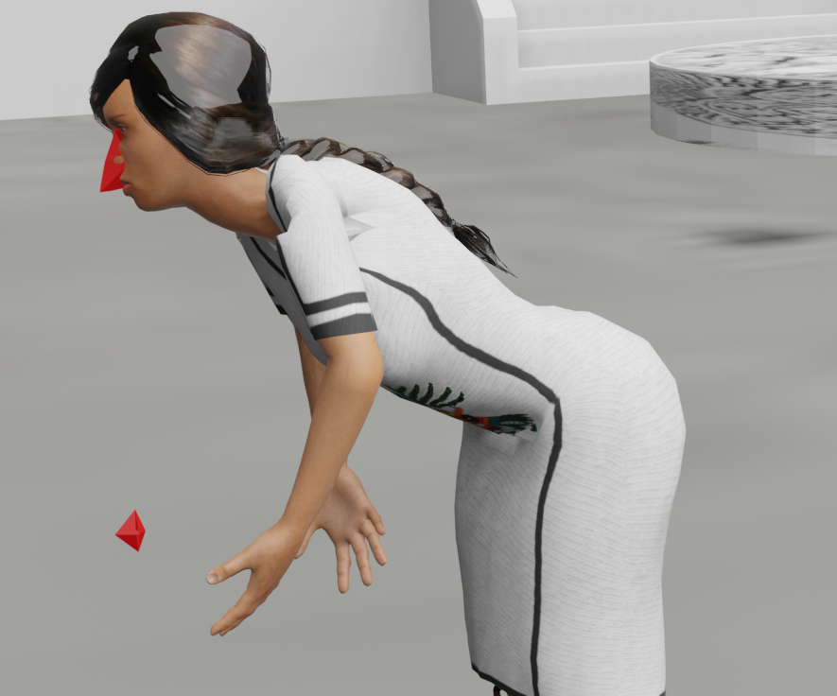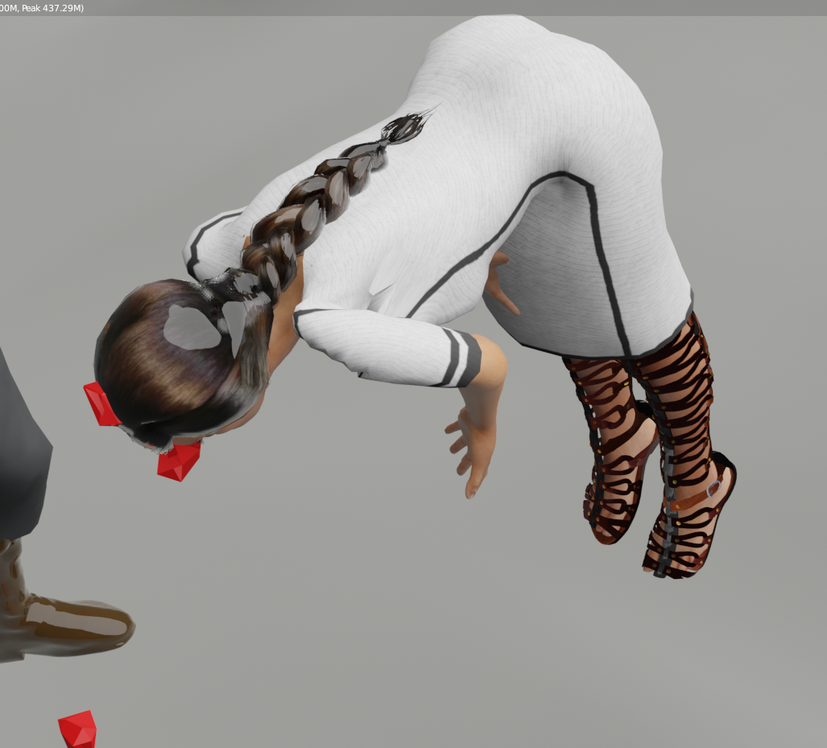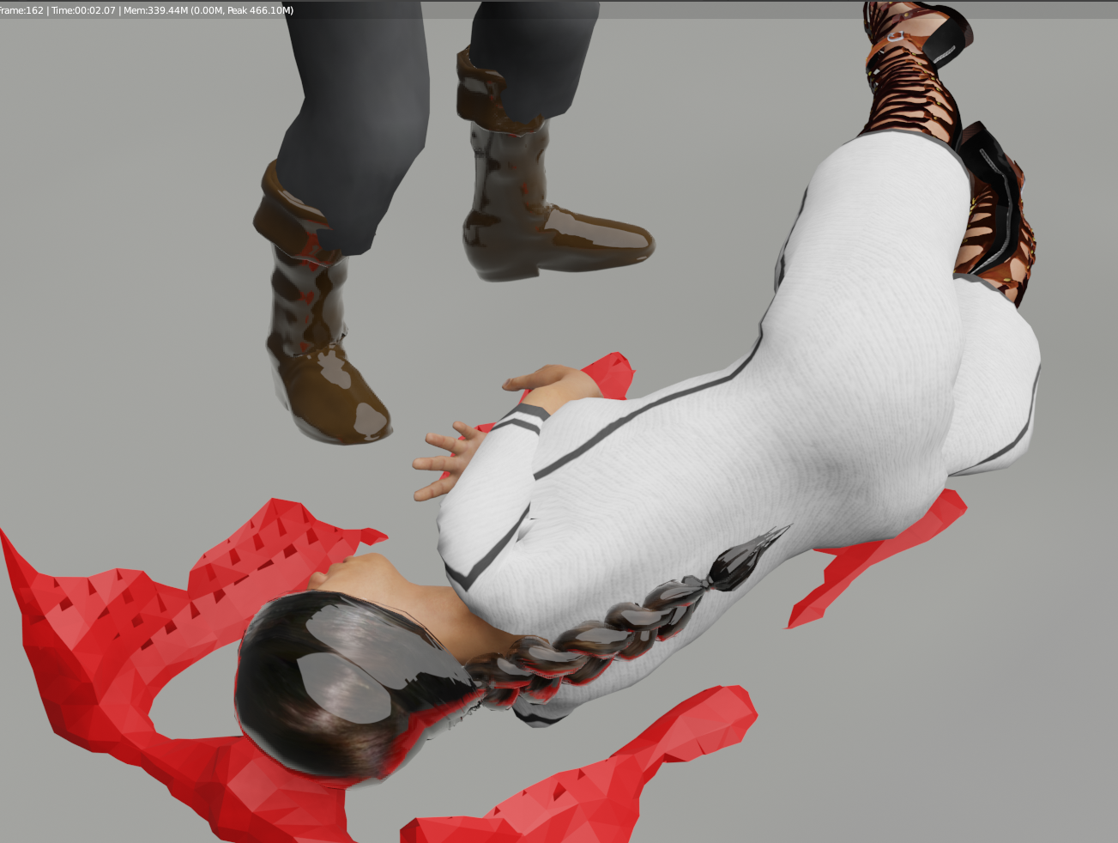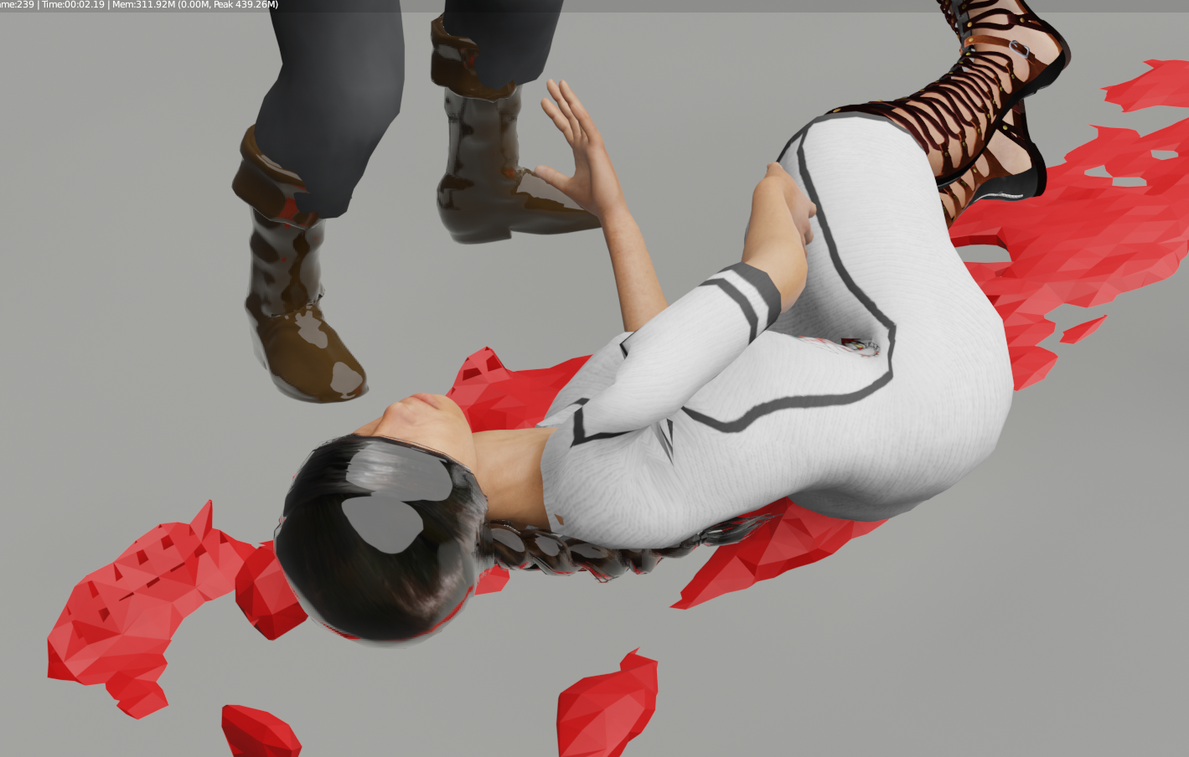

5. - Follow through and overlapping action: In the images seen above you can see this principle, since it is an animation based on real events, the laws of physics must be applied correctly.

7. - Arcs: The arcs are also an important part of the animation because they represent realistic movements focused on various purposes

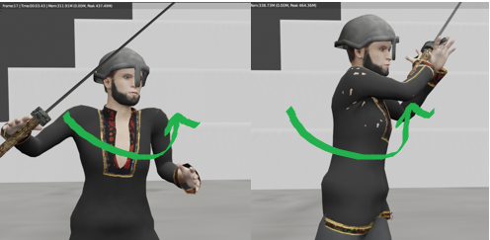

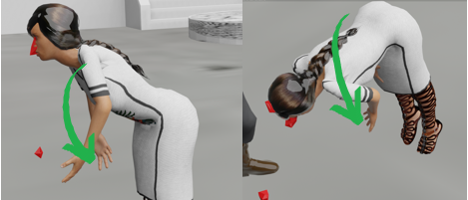

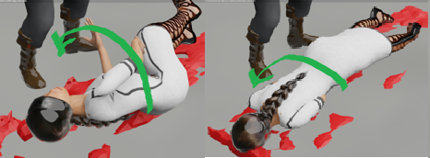

9. – Timing: Timing is important in all scenes, however in this scene the focus is that the longest time she gets mad at a dying person, hoping the desired feeling can be transmitted.

**Conclusions**

Due to current circumstances, the animation could not be completed, which, realistically, was too ambitious. The models were ready and some animations in .bvh format too. However, the time was very short for animation considering also the change in the Storyboard. Despite everything shown in this report is evidence of what I learned from computer animation, I feel that everything in the selected scene is consistent with what was planned from the beginning. Animation is an art, a systems engineer like me is limited in that part, we don't know how to appreciate it, much less create it. Using Blender in this course was the best option, this open source software is excellent, intuitive and with a lot of documentation on the web. In the end I took the idea that animation is a job with an interesting and effective methodology, I finish this course happy and wanting to learn a little more.